- Create MariaDB DB on EC2.

1. Task Title
Create and Configure MariaDB Database on AWS EC2 Instance
2. Objective
To install MariaDB on an EC2 Linux instance and create a database that can be used by applications or services.
3. Prerequisites
## AWS account with permissions to launch EC2 instances
## EC2 instance (Amazon Linux 2 / Amazon Linux 2023 / RHEL-based OS)
## Security Group allowing inbound traffic on:
>> 22 (SSH) from your IP
>> 3306 (MySQL/MariaDB) if remote access is required
## SSH key pair to access the EC2 instance
## Basic Linux and SQL knowledge

4. Step-by-Step Implementation

* INSTALL MARIADB

### Step 1: Fix the repo file

```bash
sudo tee /etc/yum.repos.d/MariaDB.repo <<EOF
[mariadb]
name = MariaDB
baseurl = https://rpm.mariadb.org/10.11/rhel/9/x86_64
gpgkey=https://rpm.mariadb.org/RPM-GPG-KEY-MariaDB
gpgcheck=1
enabled=1
EOF
```
### Step 2: Clean metadata

```bash
sudo dnf clean all
sudo dnf makecache
```
### Step 3: Install MariaDB Server

```bash
sudo dnf install MariaDB-server -y
```
### Step 4: Start & Enable MariaDB

```bash
sudo systemctl start mariadb
sudo systemctl enable mariadb
```
### Step 5: Verify

```bash
systemctl status mariadb
mysql --version
```
You should see:
```
MariaDB 10.11.x
```

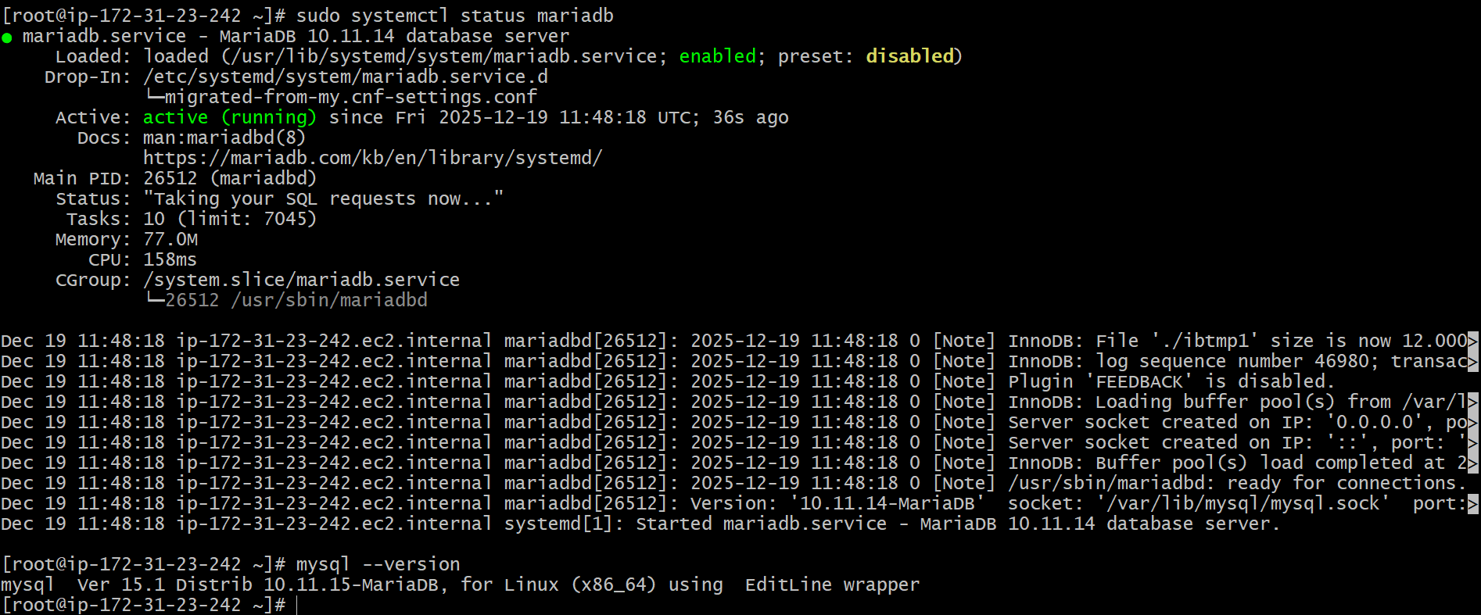

Set Environmental Variables
===========================
DBName=ec2db
DBPassword=admin123456
DBRootPassword=admin123456
DBUser=ec2dbuser

Database Setup on EC2 Instance:
===============================
echo "CREATE DATABASE ${DBName};" >> /tmp/db.setup
echo "CREATE USER '${DBUser}' IDENTIFIED BY '${DBPassword}';" >> /tmp/db.setup
echo "GRANT ALL PRIVILEGES ON *.* TO '${DBUser}'@'%';" >> /tmp/db.setup
echo "FLUSH PRIVILEGES;" >> /tmp/db.setup

mysqladmin -u root password "${DBRootPassword}"
mysql -u root --password="${DBRootPassword}" < /tmp/db.setup
rm /tmp/db.setup

To login to database
====== ==== =========== = =======
mysql -u root --password="${DBRootPassword}"

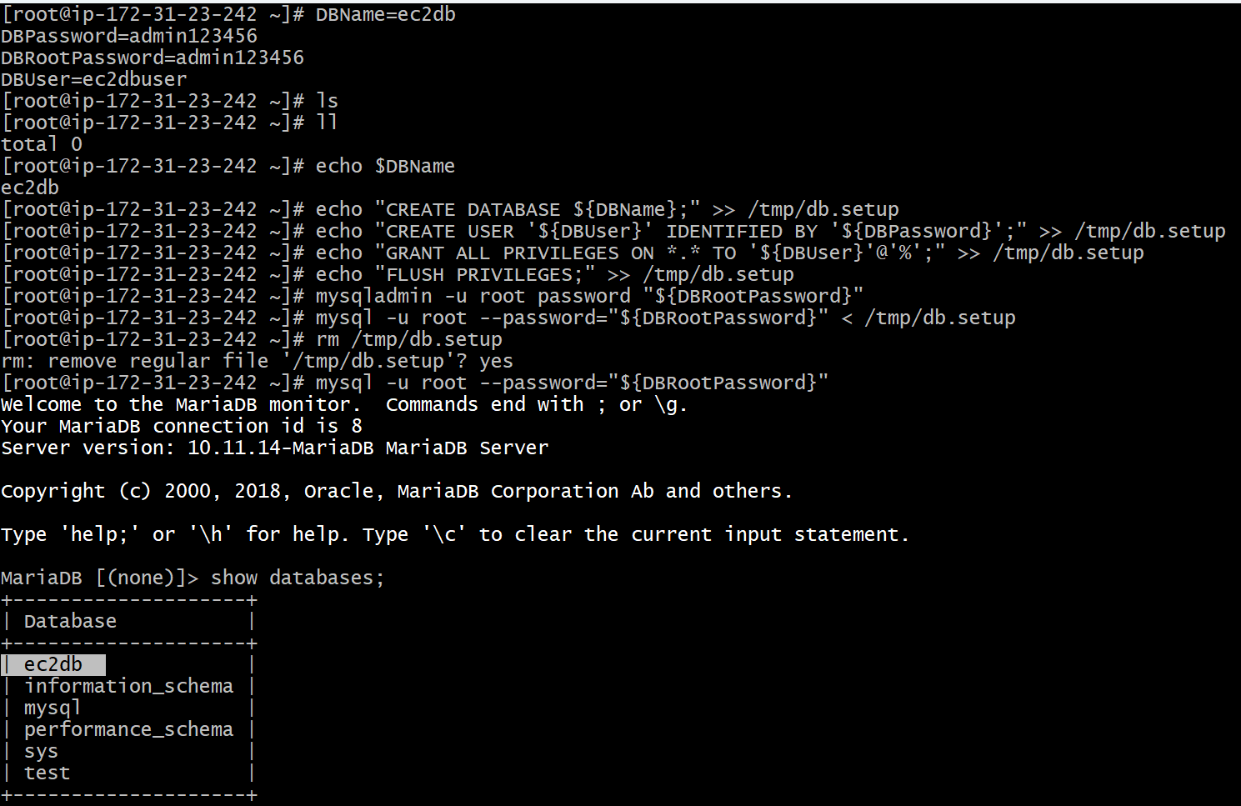

- Insert some dummy data.

Adding some dummy data to the Database inside EC2 Instance:
==========================================================
LOGIN TO DATABASE
## mysql -u root --password="${DBRootPassword}"

## USE ec2db;
## CREATE TABLE list (id INT, name VARCHAR(45), email VARCHAR(100));
## INSERT INTO list VALUES(1, 'Virat', 'virat@gmail.com' ), (2, 'Sachin', 'sachin@gmail.com' ), (3, 'Dhoni', 'dhoni@gmail.com' ), (4, 'ABD', 'abd@gmail.com' );
## SELECT * FROM list;

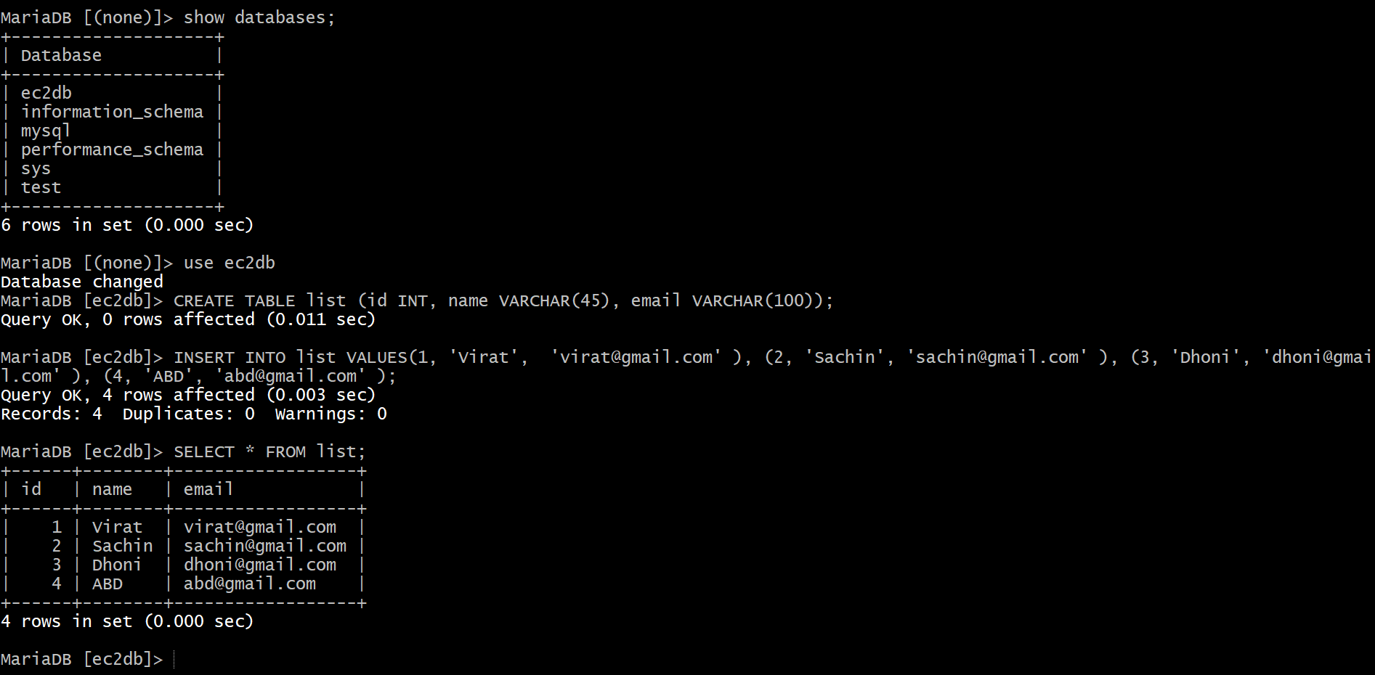

3.Take the backup of dummy data on EC2.

## Get the dump or backup of your existing DB on EC2

Command == mysqldump -u root -p database_name > file_name.sql

In my case
** mysqldump -u root -p ec2db > ec2db_backup.sql

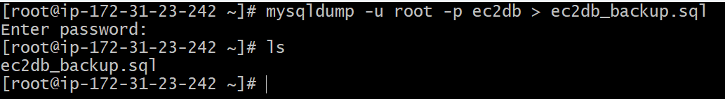

4.Launch MariaDB RDS instance.

1. Task Title

Launch MariaDB RDS Instance on AWS

2. Objective

To provision a managed **Amazon RDS** instance using the **MariaDB** engine for high availability, security, and ease of database management.

3. Prerequisites

* Active AWS account
* IAM user/role with RDS full access permissions
* VPC with at least one subnet (preferably private subnets)
* Security Group allowing inbound access on port **3306**
* (Optional) EC2 instance for database connectivity testing
* Basic understanding of AWS Console and databases

4. Step-by-Step Implementation

### Step 1: Login to AWS Management Console

* Navigate to **AWS Console**
* Search for **RDS** → Click **Create database**

### Step 2: Choose Database Creation Method

* Select **Standard create**

### Step 3: Select Engine Options

* Engine type: **MariaDB**
* Version: Select latest stable version (recommended)

### Step 4: Choose Templates

* Select based on requirement:

* **Production**
* **Dev/Test**
* **Free tier** (if eligible)

### Step 5: Configure DB Settings

* DB instance identifier: `mariadb-rds-db`
* Master username: `admin`
* Master password: Set a strong password

### Step 6: Configure Instance Size

* DB instance class:

* Example: `db.t3.micro` (Dev/Test)
* Storage type: General Purpose (gp3)
* Allocated storage: As per requirement
* Enable storage autoscaling (recommended)

### Step 7: Connectivity Settings

* VPC: Select your VPC
* Subnet group: Default or custom DB subnet group
* Public access:

* **No** (recommended for security)
* VPC security group:

* Allow inbound **3306** from application EC2 SG

### Step 8: Database Options

* Initial database name: `appdb` (optional)
* Backup retention: 7 days (recommended)
* Enable automated backups
* Enable monitoring (optional)

### Step 9: Maintenance & Protection

* Enable auto minor version upgrade
* Enable deletion protection (recommended for production)

### Step 10: Create Database

* Review all settings
* Click **Create database**
* Wait until DB status becomes **Available**

5. Validation Steps

1. Verify RDS status:

* RDS Dashboard → Instance status = **Available**

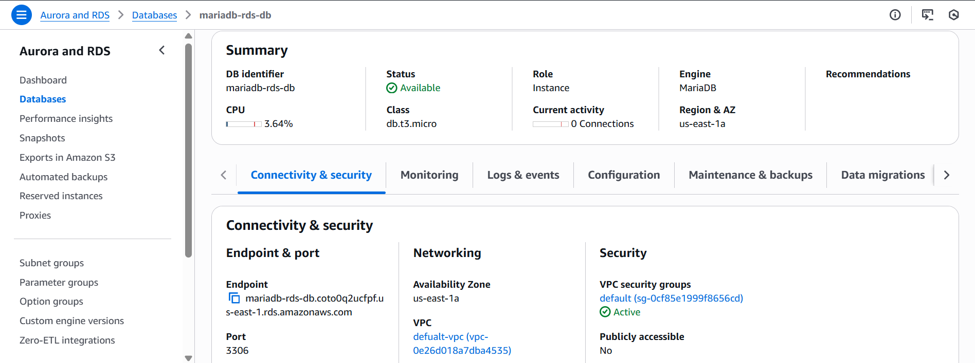
2. Note the RDS endpoint:

* Example:
mariadb-rds-db.xxxxxx.ap-south-1.rds.amazonaws.com

3. Connect from EC2:

mysql -h <rds-endpoint> -u admin -p

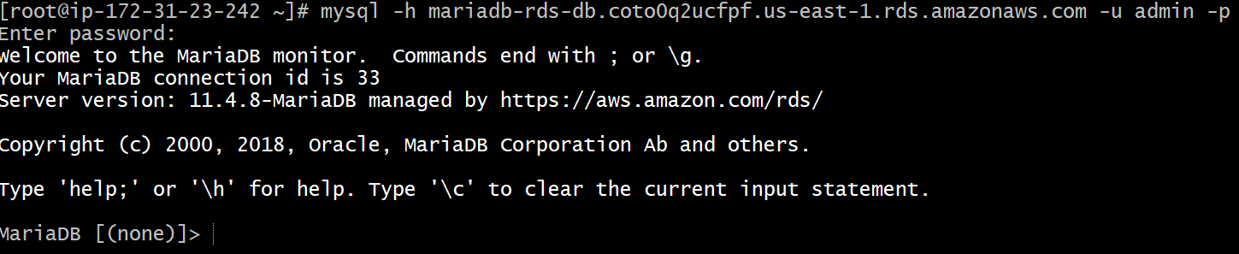

4. Validate database access:

SHOW DATABASES;

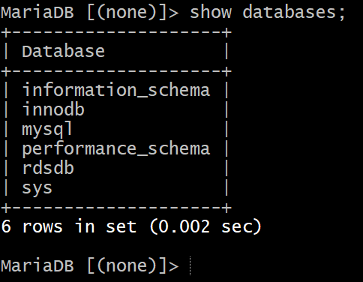

6. Conclusion

The MariaDB RDS instance was successfully launched and configured on AWS. The managed database is now ready for secure, scalable, and highly available application usage.

5.Migrate database from EC2 to RDS.

Migrating DB from EC2 to RDS:
============================
1) Get the dump of your existing DB on EC2
mysqldump -u root -p database_name > file_name.sql



2) Migrate the DB dump that you have taken in step 1 to RDS
mysql -h <replace-rds-end-point-here> -P 3306 -u <user_name> -p database_name < ec2db.sql

3) Connect to your RDS DB instance
mysql -h <replace-rds-end-point-here> -P 3306 -u rdsuser -p

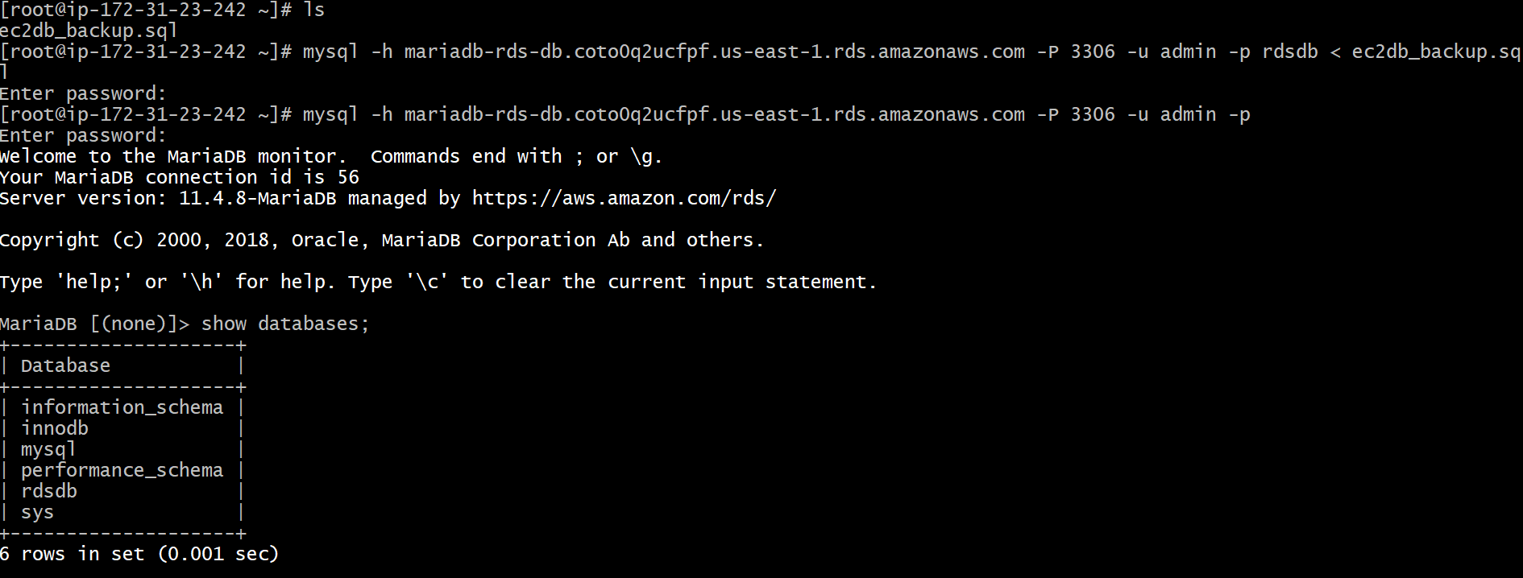

4) Switch to the database and verify the details.
USE rdsdb
SELECT * FROM list;

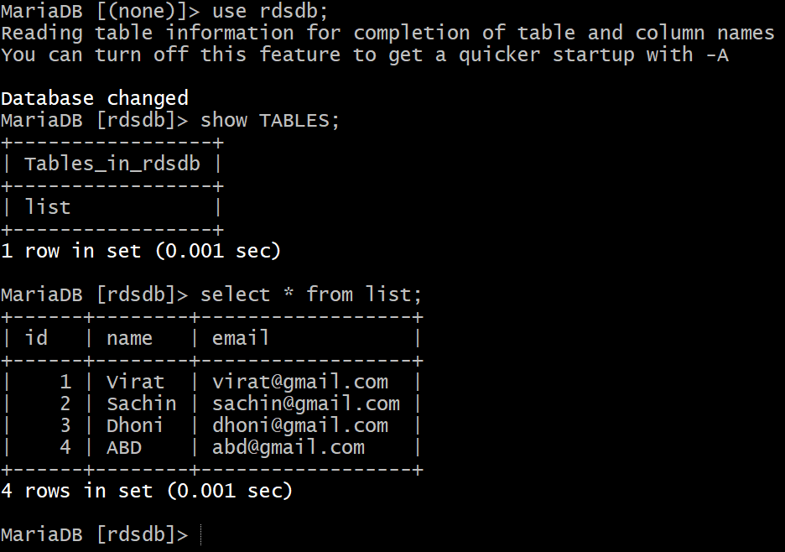

- Install MySQL DB on EC2.

1. Task Title

Install and Configure MySQL Database on EC2 Instance

2. Objective

To install and configure the **MySQL** database server on an EC2 instance for application data storage and testing purposes.

3. Prerequisites

* AWS account with EC2 access
* Running EC2 instance (Amazon Linux 2 / Amazon Linux 2023)
* Security Group allowing:

* Port **22** (SSH) from your IP
* Port **3306** (MySQL) if remote access is required
* SSH key pair for EC2 access
* Sudo/root privileges on the EC2 instance

4. Step-by-Step Implementation

### Step 1: Connect to the EC2 Instance

```bash
ssh -i <key-pair.pem> ec2-user@<EC2-Public-IP>
```
### Step 2: Update System Packages

```bash
sudo yum update -y
```
### Step 3: Install MySQL Server

#### For Amazon Linux 2023

```bash
sudo dnf install mysql-server -y
```
### Step 4: Start and Enable MySQL Service

```bash
sudo systemctl start mysqld
sudo systemctl enable mysqld
```

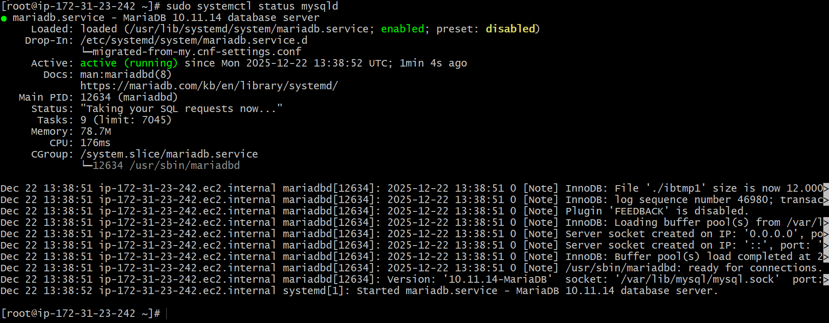

Set Environmental Variables
===========================
DBName=ec2mysqldb
DBPassword=admin123456
DBRootPassword=admin123456
DBUser=ec2mysqldbuser

Database Setup on EC2 Instance:
===============================
echo "CREATE DATABASE ${DBName};" >> /tmp/db.setup
echo "CREATE USER '${DBUser}' IDENTIFIED BY '${DBPassword}';" >> /tmp/db.setup
echo "GRANT ALL PRIVILEGES ON *.* TO '${DBUser}'@'%';" >> /tmp/db.setup
echo "FLUSH PRIVILEGES;" >> /tmp/db.setup

mysqladmin -u root password "${DBRootPassword}"
mysql -u root --password="${DBRootPassword}" < /tmp/db.setup
rm /tmp/db.setup

To login to database
====== ==== =========== = =======
mysql -u root --password="${DBRootPassword}"

5. Validation Steps

- Check MySQL service status:

```bash
sudo systemctl status mysqld
```
2. Login to MySQL:

```bash
mysql -u root -p
```
3. Verify database creation:

```sql
SHOW DATABASES;
```
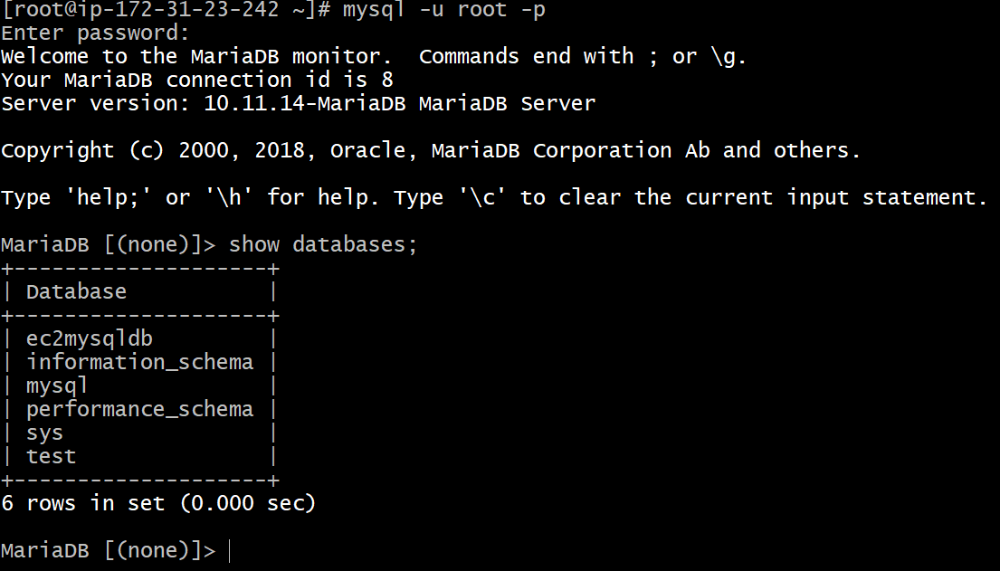

6. Conclusion

MySQL database was successfully installed and configured on the EC2 instance. The database is now ready for application use or further integration.

7.Launch MySQL RDS image.

1. Task Title

Launch MySQL RDS Instance on AWS

2. Objective

To provision a managed **Amazon RDS** instance using the **MySQL** engine for scalable, secure, and highly available database operations.

3. Prerequisites

* Active AWS account
* IAM user/role with **Amazon RDS full access**
* VPC with at least two subnets (recommended for HA)
* Security Group allowing inbound **3306** from application source (EC2 / ALB)
* (Optional) EC2 instance for connectivity testing
* Basic understanding of AWS Console

4. Step-by-Step Implementation

### Step 1: Login to AWS Management Console

* Sign in to AWS Console
* Search for **RDS** → Click **Create database**

### Step 2: Choose Database Creation Method

* Select **Standard create**

### Step 3: Select Engine Options

* Engine type: **MySQL**
* Engine version: Latest stable version (recommended)

### Step 4: Choose Template

Select based on environment:

* **Production** (recommended)
* **Dev/Test**
* **Free Tier** (if eligible)

### Step 5: Configure DB Settings

* DB instance identifier: `mysql-rds-db`
* Master username: `admin`
* Master password: Set a strong password
### Step 6: Configure Instance & Storage

* DB instance class:

* Example: `db.t3.micro` (Dev/Test)
* Storage type: General Purpose (gp3)
* Allocated storage: As required
* Enable **Storage Autoscaling** (recommended)

### Step 7: Connectivity Settings

* VPC: Select your VPC
* DB subnet group: Default or custom
* Public access:

* **No** (recommended)
* VPC security group:

* Allow inbound **3306** from EC2 security group

### Step 8: Database Options

* Initial database name: `appdb` (optional)
* Backup retention period: 7 days (recommended)
* Enable automated backups
* Enable monitoring (optional)

### Step 9: Maintenance & Protection

* Enable auto minor version upgrades
* Enable deletion protection (recommended)

### Step 10: Create Database

* Review configuration
* Click **Create database**
* Wait until status becomes **Available**

5. Validation Steps

1. Check RDS status:

* RDS Dashboard → Status = **Available**

2. Copy RDS endpoint:

```text
mysql-rds-db.xxxxxx.us-east-1.rds.amazonaws.com
```
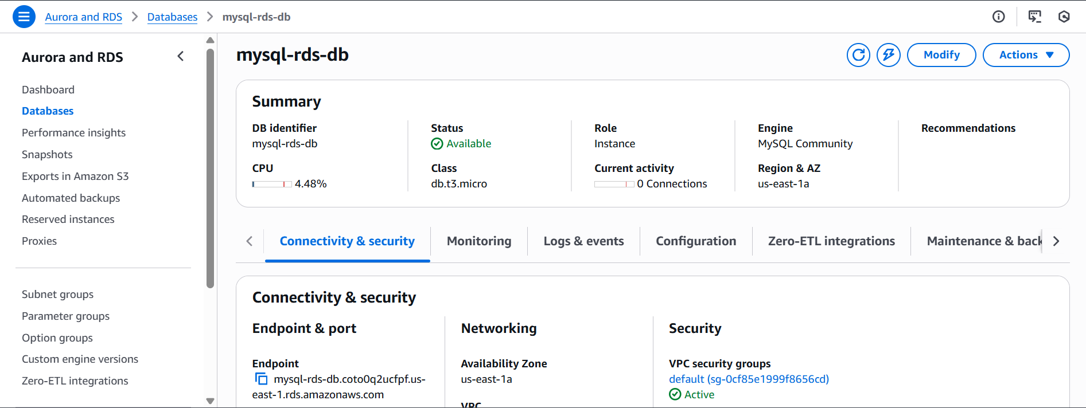

3. Connect from EC2:

```bash
mysql -h <rds-endpoint> -u admin -p
```
mysql -h mysql-rds-db.coto0q2ucfpf.us-east-1.rds.amazonaws.com -u admin -p

4. Validate database:

```sql
SHOW DATABASES;
```
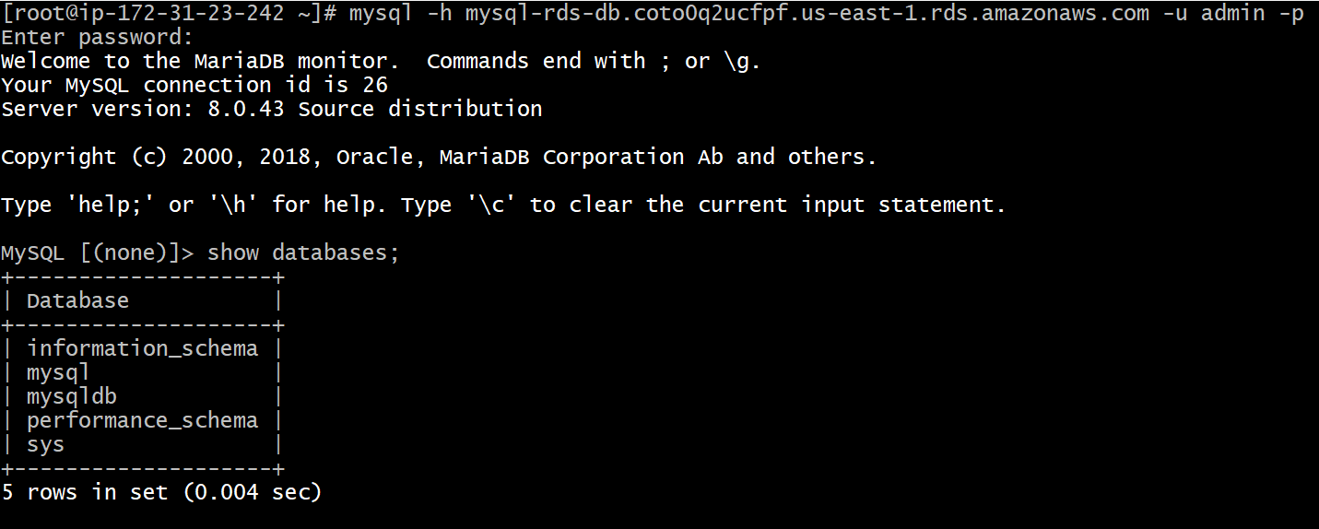

6. Conclusion

The MySQL RDS instance was successfully launched and configured on AWS. The managed database is now ready for secure, scalable, and production-grade workloads.

8.Configure Multi-AZ.

1. Task Title

Configure Multi-AZ for MySQL RDS Instance

2. Objective

To enable **Multi-AZ deployment** for a **Amazon RDS** MySQL instance to achieve high availability and automatic failover.

3. Prerequisites

* Existing **MySQL RDS** instance in **Available** state
* IAM permissions to modify RDS instances
* DB instance running in a VPC with **at least two subnets in different AZs**
* No pending maintenance or backup operations
* Understanding that a brief failover may occur during modification

4. Step-by-Step Implementation

### Step 1: Login to AWS Management Console

* Sign in to AWS Console
* Navigate to **RDS → Databases**

### Step 2: Select the MySQL RDS Instance

* Click on your MySQL RDS instance identifier
* Choose **Modify**

### Step 3: Enable Multi-AZ

* Scroll to **Availability & durability** section
* Set **Multi-AZ deployment** to **Yes**

### Step 4: Apply Changes

* Scroll down and click **Continue**

* Choose when to apply changes:

* **Apply immediately** (immediate failover)
* **Apply during next maintenance window** (recommended for production)

* Click **Modify DB instance**

### Step 5: Monitor the Modification

* Instance status changes to:

* `Modifying`
* `Backing-up`
* `Available`

AWS automatically:

* Creates a **standby replica in a different AZ**
* Configures **synchronous replication**
* Sets up **automatic failover**

5. Validation Steps

1. Verify Multi-AZ status:

* RDS Console → Database → **Multi-AZ = Yes**

2. Check Availability Zones:

* Primary AZ and Standby AZ should be different

3. Test database connectivity:

```bash
mysql -h <rds-endpoint> -u admin -p
```

6. Conclusion

Multi-AZ was successfully enabled for the MySQL RDS instance, ensuring high availability and automatic failover during infrastructure or AZ-level failures.

9.Take backup of DB and restore the DB.

Migrating DB from EC2 to RDS:
============================
1) Get the dump of your existing DB on EC2
mysqldump -u root -p database_name > file_name.sql

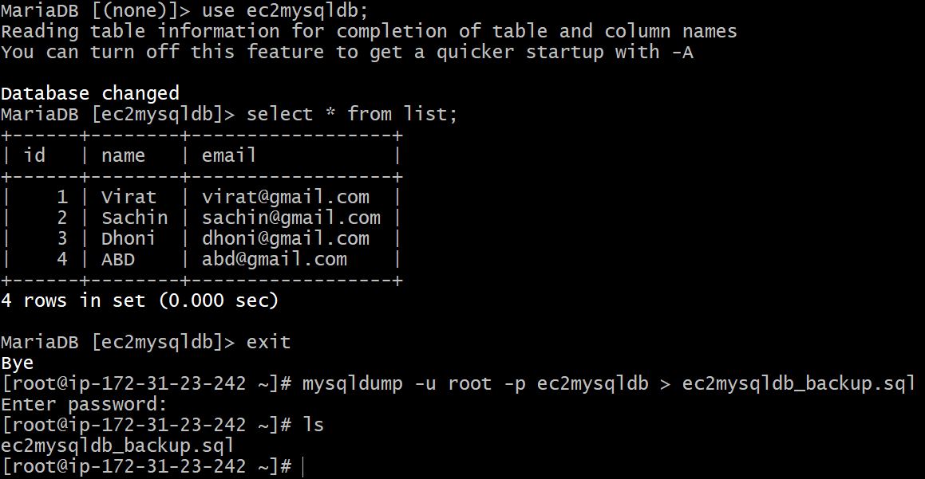

2) Migrate the DB dump that you have taken in step 1 to RDS
mysql -h <replace-rds-end-point-here> -P 3306 -u <user_name> -p database_name < ec2db.sql

3) Connect to your RDS DB instance
mysql -h <replace-rds-end-point-here> -P 3306 -u rdsuser -p

4) Switch to the database and verify the details.
USE rdsdb
SELECT * FROM table1;

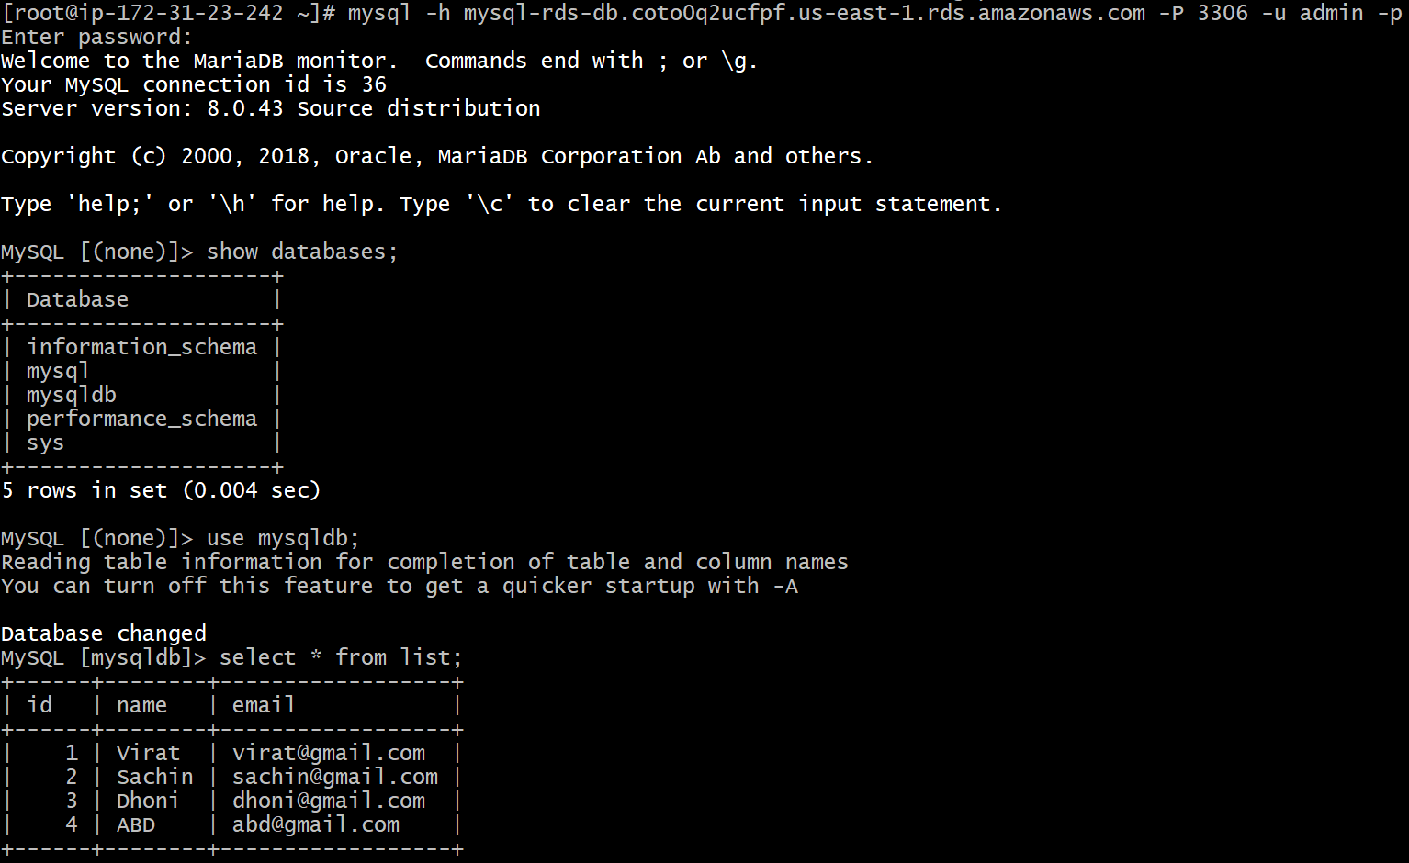
10.Create read replica.

1. Task Title

Create Read Replica for MySQL RDS Instance

2. Objective

To create a **Read Replica** for a **Amazon RDS** MySQL database to improve read scalability and reduce load on the primary database.

3. Prerequisites

* Existing **MySQL RDS** primary instance in **Available** state
* Automated backups enabled on the primary DB
* IAM permissions to create and modify RDS resources
* Source DB must use **General Purpose (gp2/gp3)** or **Provisioned IOPS** storage
* Source DB should not be in the middle of maintenance or backup
* VPC and security groups properly configured

4. Step-by-Step Implementation

### Step 1: Login to AWS Management Console

* Sign in to AWS Console
* Navigate to **RDS → Databases**

### Step 2: Select Source MySQL RDS Instance

* Click on the **primary MySQL RDS instance**
* Click **Actions → Create read replica**

### Step 3: Configure Read Replica Settings

* DB instance identifier: `mysql-read-replica-1`
* Destination Region:

* Same region (for low-latency reads), or
* Different region (for disaster recovery)
* DB instance class:

* Example: `db.t3.micro` (Dev/Test)
* Storage type: Inherit from source DB

### Step 4: Connectivity & Network

* VPC: Same as source (recommended)
* Subnet group: Default or custom
* Public access:

* **No** (recommended)
* VPC security group:

* Allow inbound **3306** from application servers

### Step 5: Additional Settings

* Enable Enhanced Monitoring (optional)
* Enable Performance Insights (optional)
* Set maintenance window (optional)

### Step 6: Create Read Replica

* Review configuration
* Click **Create read replica**

AWS will:

* Enable **asynchronous replication**
* Create a **read-only replica**
* Continuously sync data from primary DB

5. Validation Steps

1. Verify replica status:

* RDS Console → Read Replica status = **Available**

2. Confirm replication source:

* Replica → **Replication role: Replica**
* Source DB shown correctly

3. Connect to Read Replica:

```bash
mysql -h <read-replica-endpoint> -u admin -p
```

4. Verify read-only behavior:

```sql
SHOW DATABASES;
INSERT INTO test_table VALUES (1);
```
(Expected: Write operation fails)

6. Conclusion

The Read Replica was successfully created for the MySQL RDS instance, enabling horizontal read scaling and improved database performance without impacting the primary database.

